Experiment 1
AIM
To execute and study the rm, users, and tree commands in Kali Linux and understand their uses.
COMMANDS AND THEIR USE
Command | Use
rm | Used to remove/delete files.
users | Used to display the users currently logged into the system.
tree | Used to display files and directories in a tree-like structure.
Commands to Execute
1. rm command
touch test.txt
rm test.txt
Use: Deletes test.txt.
2. users command
users
Use: Shows the users currently logged into Kali Linux.
3. tree command
tree
Use: Displays the current directory and its files/folders in tree format.
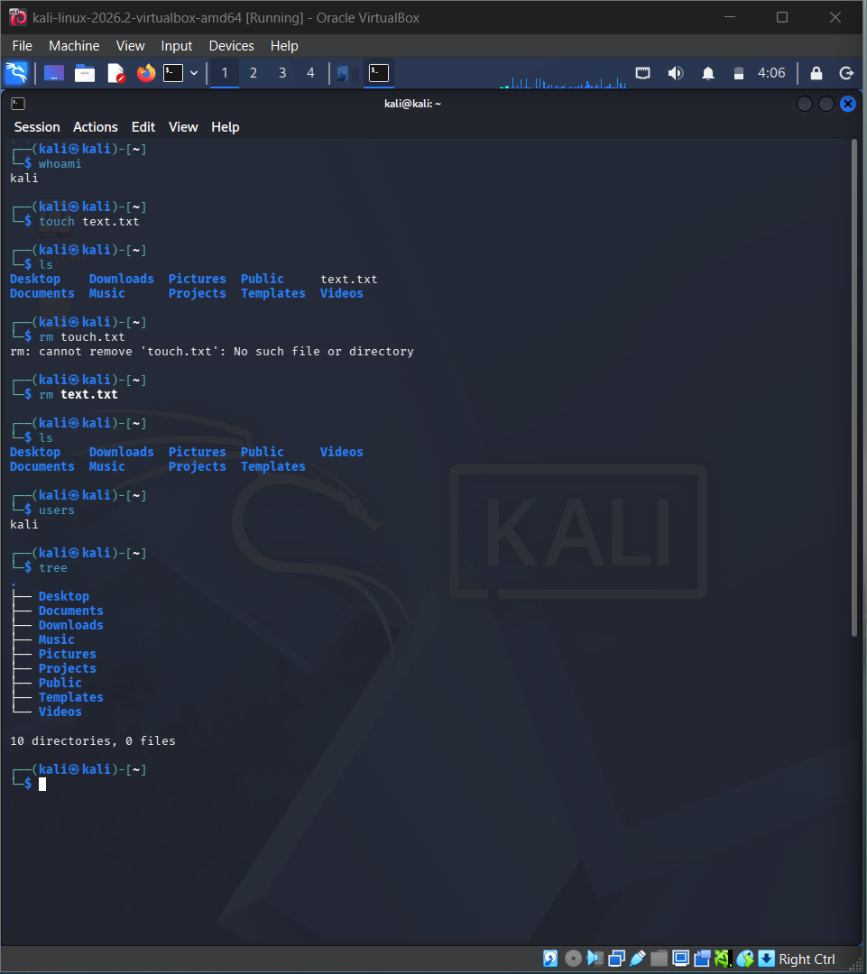
RESULT
Thus, the rm, users, and tree commands were successfully executed in Kali Linux and their uses were studied.

